* Create a web form with the use of HTML, CSS, JS. (Bootstrap/jQuery can be used)
  1. Form will include fields: Employee Name, Employee Id, Employee Birthdate, Gender, Mobile Number, department.
  2. Rules: Use JS to format number > XXX-XXX-XXXX
  3. Use JS formatting for date > MM-DD-YYYY
  4. Department dropdown> value list> IT, HR, Management
  5. Give save button below form and one table when user click on save validate all the above fields as required and show it on table using JS function.
  6. Give filter table option just one search box above the table. When user starts typing it should show filtered records in table matching user input string. (Can use bootstrap table)

The output should have the validation and search column. Find the attached screenshots for reference:  
  
1.) The list of candidates and search option should appear in the given manner. 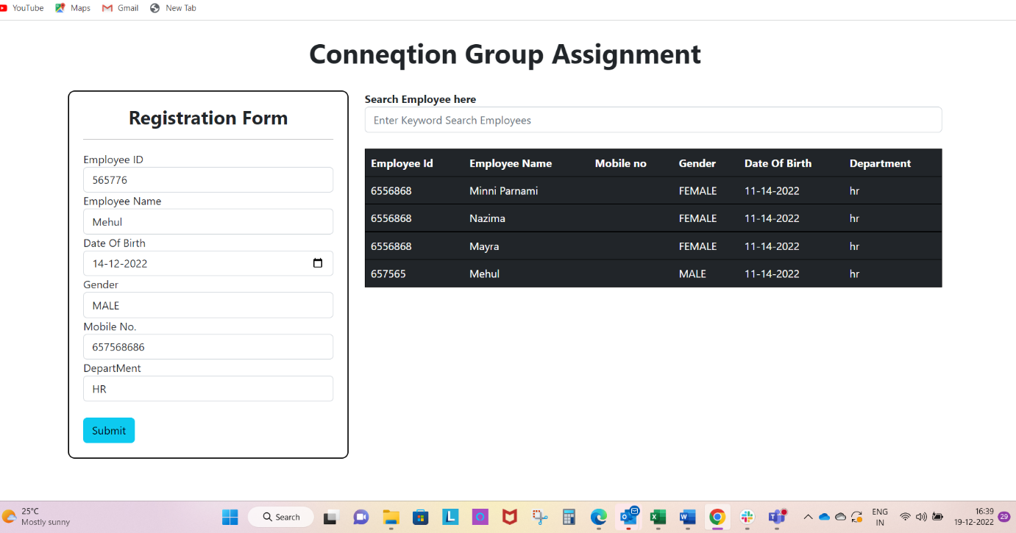

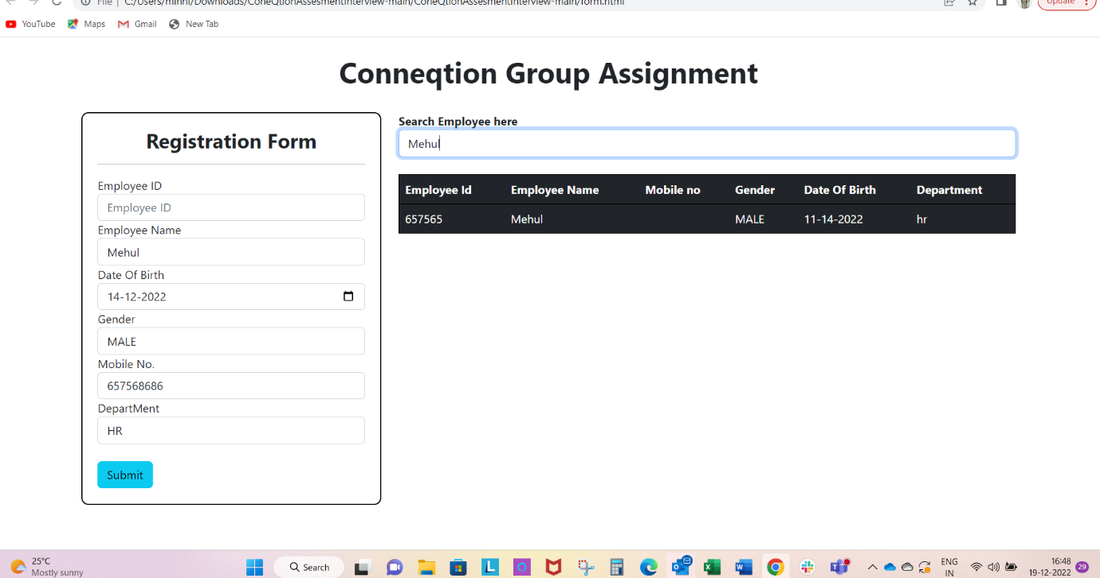

2.) The list of departments should include the following: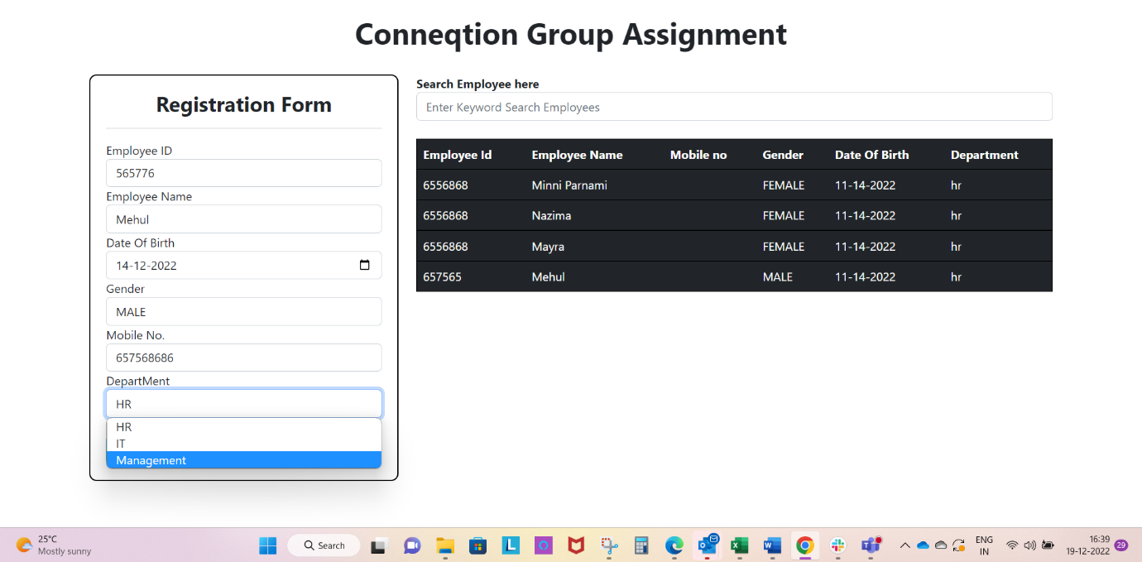

3.) The validation pop-up should appear if any input is not submitted.